The Lightweight IBM Cloud Garage Method for Data Science

Architectural Decisions Document Template

Project Title: US Covid-19 – Analyze and Predict Daily Deaths (Dependent Variable) using an Independent variable (Daily Cases).

by Bawo Kijera,
Date: February 2021.

Architectural Components Overview

The project follows the lightweight IBM Cloud Garage Method process model for data science which a process to map individual technology components to the reference architecture. This method does not include any requirement engineering or design thinking tasks. Because it can be hard to initially define the architecture of a project, this method supports architectural changes during the process model.

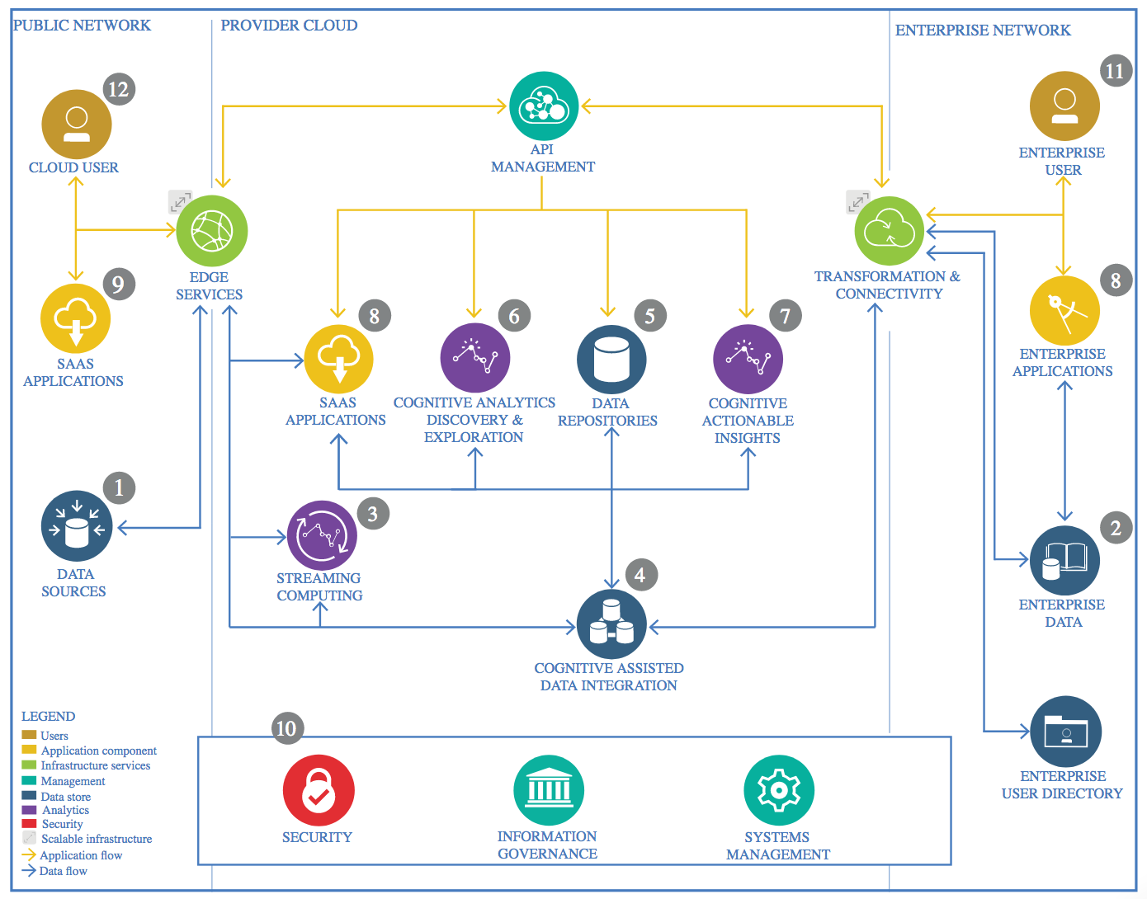
IBM Data and Analytics Reference Architecture. Source: IBM Corporation

Data Source

The data was extracted from the link below, it is updated in real time. The New York Times release a series of data files with cumulative counts of covid-19 cases and deaths in the US at the state and county level.
https://github.com/nytimes/covid-19-data

Technology Choice

With computer and internet one can through the data source link above and explore the data of your choice.

Justification

Computer and internet to access the data is necessary.

Enterprise Data

New York Times shares real time data that was precisely define and easily integrated for both internal and external use.

Technology Choice

Spark analytic engine for data processing in IBM cloud is the technology used in this data analysis. Spark provide an interface for programming with data parallelism.

Justification

After creating the Notebook, clone the data from the data source to gain access to the desired file for analysis.

Streaming analytics

The NYTimes on github provide a real-time data. This make the data extraction, transformation and loading easier to access the most updated recent values on the dataset, the streaming analytics is live, all the plots and models shows live data results as they are updated in nytimes.com/interactive/2020/us/coronavirus-us-cases-html.

Technology Choice

This process require internet access and a Jupiter notebook framework.

Justification

IBM Cloud, Jupiter notebook, pyspark, python, sparkml were technology choices.

Data Integration

New York Times covid-19 data combines the necessary data in the repository that provide us a unified view of the virus cases and deaths counts in the US which is a subset of the scope of this project to determine the parallel relationship between independent and dependent variable.

Technology Choice

In Jupiter Notobook, Applied ETL, extract the data from github by git cloned and then transformed the data into the desired result for modeling.

Justification

Jupiter Notebook, programming technologies like python, spark and machine learning models.

Data Repository

Technology Choice

The analysis is done locally on a local machine where there are different files and directories to access the specific file. The final data was pushed to a Github repository after completion and is also stored on IBM Cloud storage. It can be access from the repository by the public.

Justification

IBM cloud pak for data provide the environment with python spark integration with different plans available depending the data usage in ETL and modeling.

Discovery and Exploration

Technology Choice

Certain discoveries were made in the ETL, the total daily cases and deaths from the data on each day was actually carried over to the next day as the total cases or deaths on that specific day so this values does not represent or shows the actual real cases or deaths of the day, a method was applied to get the right number of cases and deaths on each day, this helps the efficiency of our machine learning models and helps integrate featuring engineering.

Justification

All this data exploration is done in languages mostly used in data science projects and the environment most suitable for the analysis.

Actionable Insights

Technology Choice

It is part of the project to get it done with the right datasets from a right source and able to predict with different model validation accuracies.

Justification

Of course every data scientist or student needs a better functional environment and the most flexible language in your analysis but preferably what the project required.

Applications / Data Products

Technology Choice

Human sense will interpret as daily cases or monthly cases increase, the daily death outcome will also increase, if there is no cases then there will be death cases but we want to apply a machine learning model after ETL and feature engineering to tell what human sense may predict. The accuracy of the model tells us the relationship between the dependent variable and independent variable. This is in inline with what human may forecast about daily deaths considering daily cases. Therefore effort needs to be done on how to minimize or reduce the number of cases or completely bring them down to zero to avoid casualty counts on the population. Analyzing daily cases is not part of this project where mask use and vaccination will play a fine role in determining or predicting the daily cases. Unfortunately vaccines were introduced recently and clearly vaccine intake will lower the rate of infections as we go through theses crazy times.

Justification

The different models used in forecasting shows parallel relationship between the dependent and independent variable.

Security, Information Governance and Systems Management

Technology Choice

IBM cloud is a secured technology in data analysis except that if the amount of data usage exceeds the capacity of the environment in a certain period of time, you will run into storage shortage. The data source information is accurate and available in real-time and accessible.

Justification

IBM Cloud Pak for data and NY Times on GitHub shows proofs of security and better data system management in the handling the data and executing data analysis techniques.

